Cook Island Urogynaecology Health Specialist Visit 2025

Objective

- Provide treatment for female urinary incontinence and pelvic organ prolapse – both surgical and conservative
- Provide support to the local Gynaecologist, including surgery on patients with non Urogynaecological problems
- Assess as many patients as possible from the outer islands, visiting for the Constitution celebrations, for serious Gynaecological problems.

Team 2025

New Zealand | Cook Islands
Dr Mairi Wallace – Gynaecologist/Urogynaecologist | Dr Kevin Bisili - Gynaecologist
Dr Michael Kalkoff – Anaesthetist | Ms Maryann Pakitoa – Registered Nurse, Te Marae Ora
Ms Shelley Solomon – Pelvic Health Physiotherapist
Ms Tina Kusser – CNS Urogynaecology | Ms Joyce Sakai – Charge Nurse Theatre
Ms Rene Kalkoff – RN, post grad diploma Advanced Nursing.

Dr Mairi Wallace, Shelley Solomon (Physiotherapist) and Tina Kusser (Clinical Nurse Specialist), work together in a practice in Whangarei, New Zealand. Dr Michael Kalkoff is the regular anaesthetist for Mairi’s weekly theatre list. We are used to working together and as much possible we follow the same guidelines and principles as we would for our patients in New Zealand. This year Tina had to leave early and therefore Rene Kalkoff (Registered Nurse) replaced her during the second week.

Mission
This year the Cook Islands celebrated 60 years of independence. To honour the occasion boats were commissioned to bring people from the outer islands to Rarotonga. Te Marae Ora (TMO) took the opportunity to provide as many people as possible with health checks and routine screening that they might not otherwise be able to access. All women presenting for mammograms or cervical smear tests were asked about urinary and prolapse symptoms and offered an appointment at Gynaecology Outpatients clinic. Patients were also asked screening questions for possible signs of endometrial cancer. The first week of our visit had initially been set aside for outpatient clinics and the second week for surgery. As it turned out the boats from the Northern Group were delayed and many women had to be seen in clinic during our second week. We therefore had a day of surgery during the first week and a day and a half of clinics during the second week. Unfortunately, without Tina, our Urogynae Clinical Nurse Specialist, we were unable to perform urodynamics during the second week.
Teaching
Although Tina was with us for only one week, she spent a morning with clinic nurse Maryann Pakitoa, sharing her expertise on managing vaginal ring pessaries. As neglected pessaries can cause significant morbidity, correct management is essential.
Rene Kalkoff is a nurse educator. During her week in the surgical ward, she took the two new graduate nurses under her wing and ensured they learnt as much as possible about post operative patient care.
The two doctors did not get a chance to do any formal teaching but as always taught as they worked. The Urogynae team was also able to attend a Urogynae MDM remotely.
The local physiotherapist (Simran) spent some time with Shelley in clinic, learning about pelvic floor anatomy and function, bladder and bowel function, and how to teach pelvic floor muscle exercises correctly and appropriately. She was advised how she could apply this knowledge to patients she works with in the Cook Islands. Nurse Maryann Pakitoa was also present in clinic and assisted Shelley with many of the outpatients she saw, also gaining knowledge and skills in this area.

Clinical work
In total 54 women were seen in Outpatients Clinic, 45 of these were new patients the others follow ups from previous years.
One of the patients for follow up had presented to clinic on the last day of our trip in 2024. She had had a polypropylene mid-urethral tape, for urinary incontinence, inserted in France 10 years prior. Ever since then she had been in pain and had symptoms suggestive of urinary obstruction. All I was able to do in Outpatients Clinic in 2024 was inject steroid over the tape. When she presented this year, she had far less pain and was looking far better in herself. This time we were able to perform Urodynamic Studies and confirm that she had urinary obstruction. I was able to divide the tape in theatre under general anaesthetic and repeat the steroid injection.
We saw two patients with what appeared to be advanced cancer. One of these was a 43-year-old patient from Mauke with what appeared to be either stage 3 cervical cancer or an advanced endometrial cancer. She was referred to Middlemore hospital in Auckland for treatment. The other patient aged 58, had BMI 65, and at Hysteroscopy had a vascular tumour obscuring the endometrial cavity. Sadly, she died of a pulmonary embolus after the team had left Rarotonga and never made it to Auckland.
Another interesting case was a lady from the remote island of Pukapuka. She had miscarried while on the 7-day voyage from Pukapuka to Rarotonga. By the time she reached us she was severely anaemic. While counselling her for surgery to have the remaining products of conception removed, she asked if she could have her “tubes tied”. She was 40 and had 6 children. For subsequent visits I feel I should offer this service more often. The laparoscopic equipment is usually used for appendicectomies and perfectly adequate for salpingectomy.
We had expected to see more patients, many women however told us that they didn’t know about our visit.

Clinic Patients

45 new patients
- Rarotonga – 36
- Outer islands - 8
- Patients for physiotherapy – 24
  - In patients – 4
  - Outpatients -20
- Patients for urodynamic studies – 6
- Flexible cystoscopy – 5
  - Out patients – 4
(Intravesical Botox in OT – 1)
- Ring pessaries – 8
  - Follow up – 5
  - New – 2

Mid-urethral Sling Audit
There is much controversy surrounding the use of polypropylene tape for the treatment of urinary incontinence. There is some evidence to show that complications can arise years after the tape was inserted. Therefore, it is recommended that patients are followed up. This year Shelley and Maryann tried to contact every patient that had had mid-urethral tape inserted in the last 10years. Thirty-five mid-urethral tapes have been inserted in the last 10 years. Of these patients, 4 have died and 3 now live overseas. Of the remaining 28, Shelley and Maryann were able to contact 19. Four patients have been asked to return to clinic in 2026. There were no major complications recorded in any of these patients.

Pelvic Health Physiotherapy
Due to a lower number of surgeries this year, Shelley had fewer post-operative patients to see on the ward. However, she assessed and treated 20 patients in the outpatient clinic. These included individuals with symptoms suitable for conservative management, those not appropriate for surgery, and those who chose to trial conservative options before considering surgical intervention. Presentations in the outpatient clinic included stress incontinence, urgency, urge incontinence, difficulty with bladder and bowel emptying, pelvic pain, and dyspareunia. In addition, as a clinician trained in pessary fitting and management, Shelley was able to assist several patients with pessary assessment, fitting, and ongoing care.

Surgery
We didn’t do as many operations as in previous years, the reason for this I believe is multifactorial. Urinary incontinence and pelvic organ prolapse are chronic conditions, it therefore makes sense that the numbers are gradually diminishing. As a result, we can now broaden the scope of the types of patients we are able to see. Another factor was that many women were involved in the Constitution celebrations and therefore unable to take time off to have surgery. We have a list of women who will return next year for their operations. I was however able to do laparotomies on two patients who had been waiting months for surgery for large, benign ovarian cysts. I was also able to do a hysteroscopy and at the same time insert a Mirena for a woman at high risk of developing endometrial cancer.

OPERATION (12) | INDICATION | AGE | BMI | ISLAND
Hysteroscopy and polypectomy | Endometrial polyp | 79 | 34 | Rarotonga
Laparotomy and oophorectomy | Large ovarian cyst | 42 | 24.8 | Rarotonga
Hysteroscopy D&C | Post Menopausal Bleeding | 66 | 30 | Rarotonga
Vaginal biopsy and examination under anaesthetic | Suspicious vaginal lesion | 80 | 23.4 | Mauke
Cystoscopy and intravesical Botox | Overactive Bladder | 67 | 47.6 | Rarotonga
Cystoscopy and division of mid urethral tape and steroid injection | Urinary obstruction and pain | 65 | 22.7 | Rarotonga
Hysteroscopy D&C, cystoscopy and cervical biopsies | Uterine/cervical cancer | 43 | 39 | Mauke
Laparotomy and oophorectomy | Complex ovarian cyst | 46 | 27 | Rarotonga
Posterior repair and perineorraphy, Hysteroscopy D&C and insertion of Mirena | Symptomatic rectocele and post-menopausal bleeding | 67 | 61 | Rarotonga
Vaginal hysterectomy and AP repair | Menorrhagia and symptomatic prolapse | 49 | 32.5 | Rarotonga
Hysteroscopy | Post menopausal bleeding | 58 | 65 | Rarotonga
ERPOC and laparoscopic bilat salpingectomy | Incomplete miscarriage and desire for sterilisation | 40 | 44.9 | Pukapuka

Looking Ahead
I was able to have a constructive conversation with Dr Deacon Teapa – Director of Hospital Services - on how to improve our visits and how best to use our time.

To address the problem of people apparently not knowing we are on the island or not understanding what services we offer we discussed advertising strategies. The New Zealand Team have agreed to make a video. Two to three weeks prior to our visit an advertisement, including our video, could be aired on Cook Island News. I need to design a screening questionnaire for the clinic nurses. In addition, we have created a leaflet detailing who we are and what we do and when we will next be in the Cook Islands. Once this is approved by TMO, the aim is that it can be placed in GP practices and outpatient clinics, including on the outer islands.
The problem of seeing women from the outer islands was once again addressed. Deacon asked if we could perhaps come for three weeks. This is not something the team could do on a regular basis as any time spent in the Cook Islands is time away from our own patients in New Zealand. We have thought if we could persuade Air Rarotonga to help and enable us to fly directly from one island to the other, instead of backwards and forwards to Rarotonga, we could get at least three outer islands per visit.
Michael Kalkoff and I were also introduced to Dr Dyxon Hansell, surgeon with WHO. It’s always both useful and encouraging meeting other health professionals committed to improving health services in the Pacific.

Thanks
None of this could have been achieved without generous donations:
Endoventure – 1. Urodynamics machine plus the disposable sensors and filling tubes necessary for doing urodynamic tests. 2. i-Stitch for doing sacrospinous fixation.
Obex- Flexible cystoscopes – for the first time enabling us to do cystoscopies in the outpatient setting and inject Botox into the bladder.
Kensington Hospital – Botox and two cystoscopy needles as well as the lone of the instruments used for doing sacrospinous fixation.
Northland Gynaecology- the loan of the cystoscopy monitor, plus reusable instruments to stay in Rarotonga.
J&J – sutures
Hallmark Surgical – ring pessaries
REM Systems – Bladder scanner.
Putiputi Charitable Trust – Surgical instruments and an ongoing connection with our donors and other interested parties.

Dr Mairi Wallace
Whangarei
Northland
August 2025
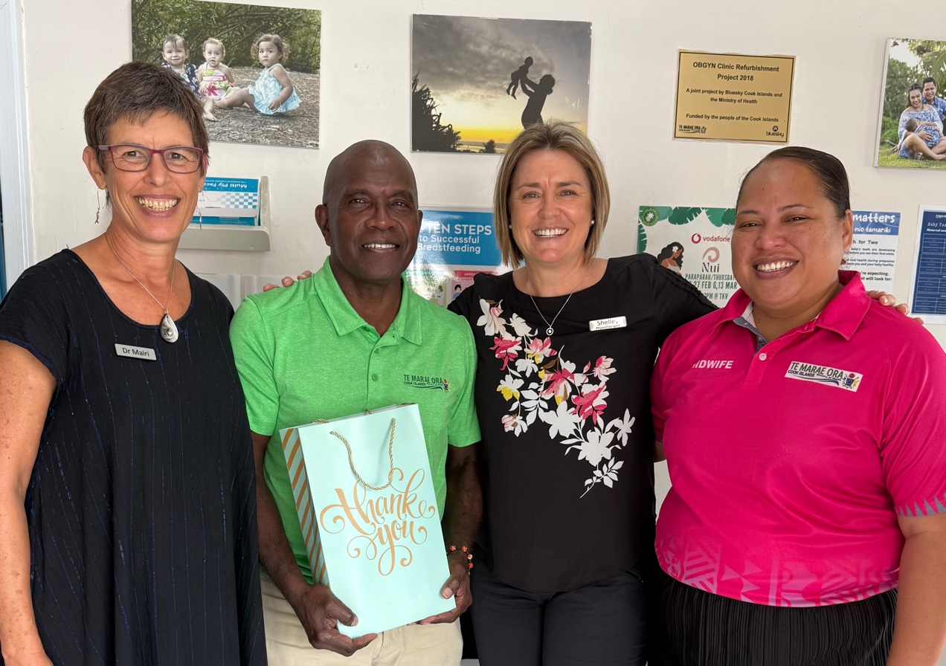
Clinic team: Drs Mairi Wallace and Kevin Bisili, Shelley Solomon physiotherapist and Registered Nurse Maryanne Pakitoa.
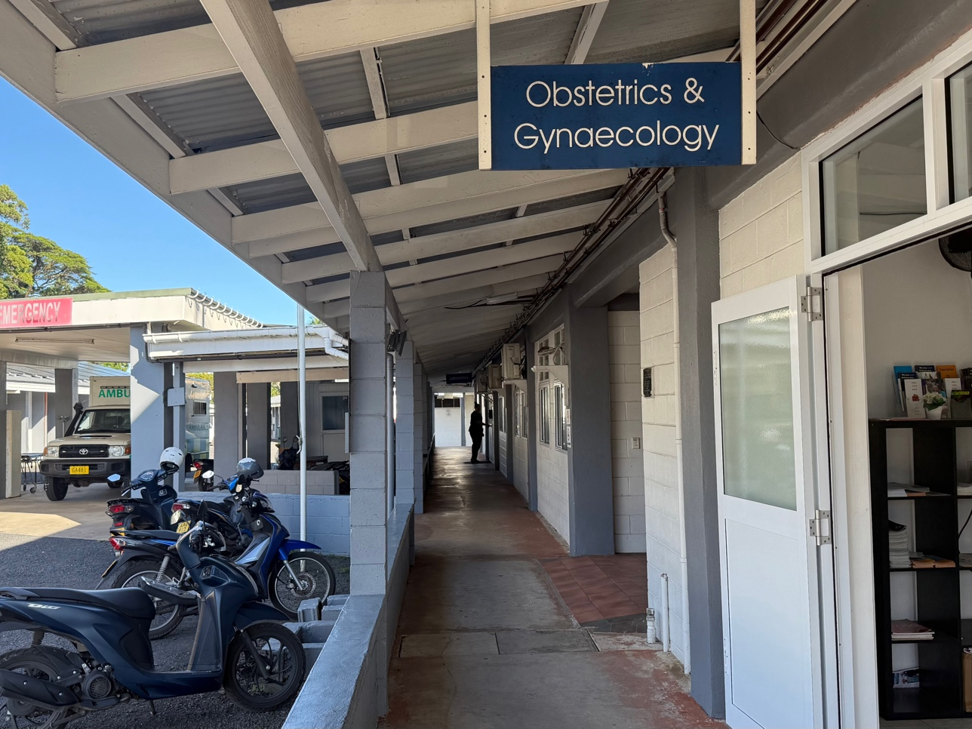
Out Patients Department
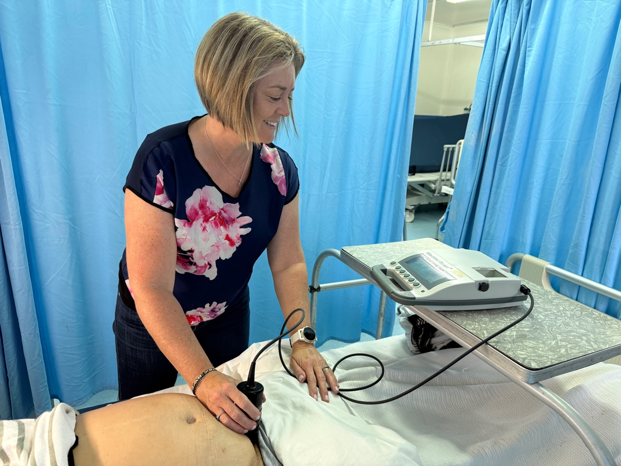
Shelley with the bladder scanner, leant to us by REM.
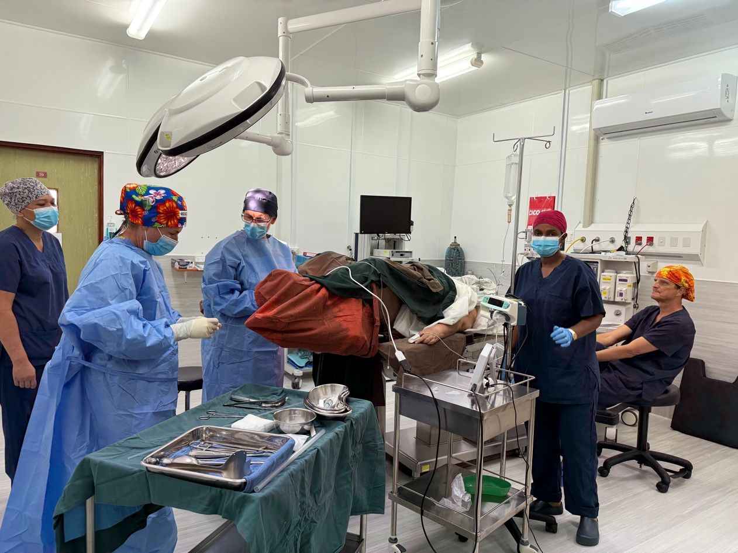
Injecting Botox into a bladder, made possible by Pusen and Kensington Hospital
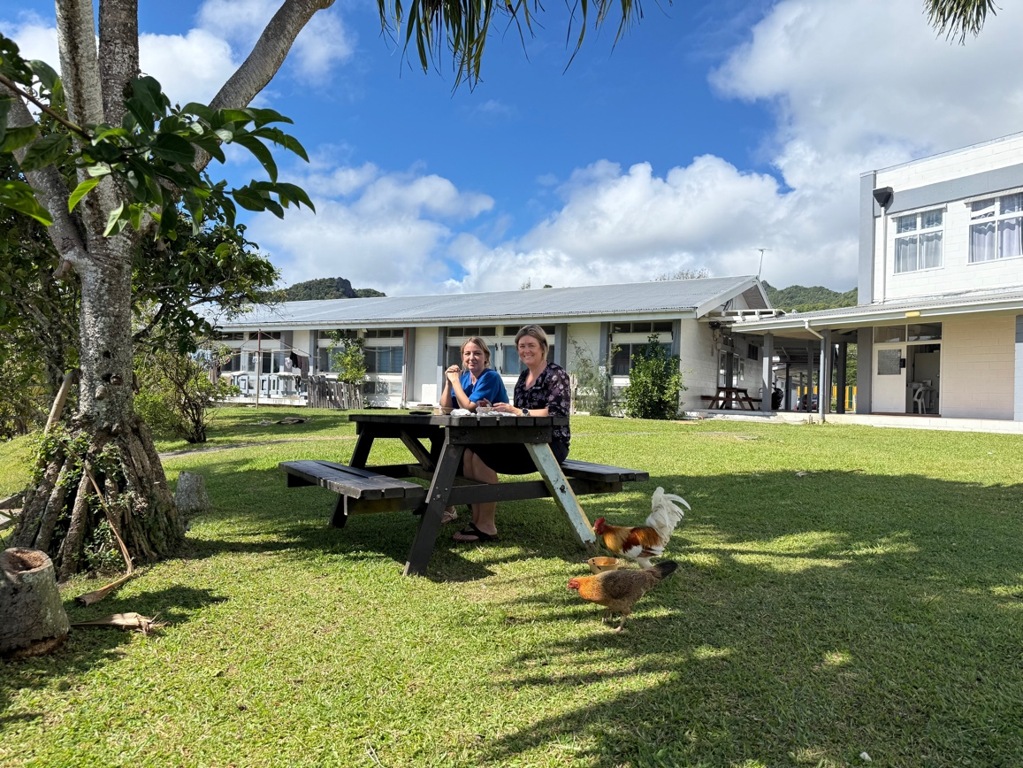
Tina and Shelley in the hospital grounds, taking a well-earned lunch break.
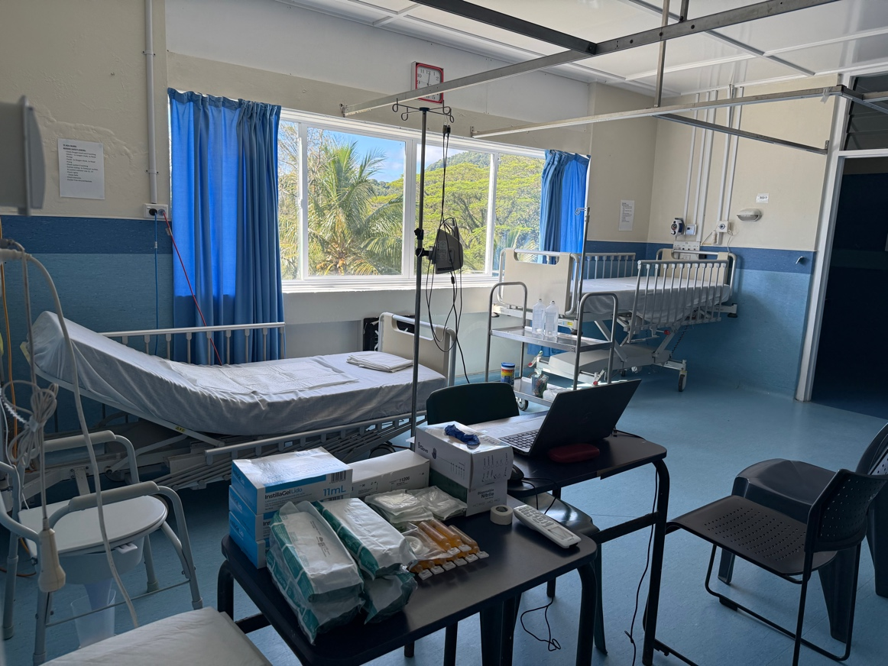
Room set up for doing Urodynamics tests - thanks to Endoventure, and flexible cystoscopies, thanks to Pusen.
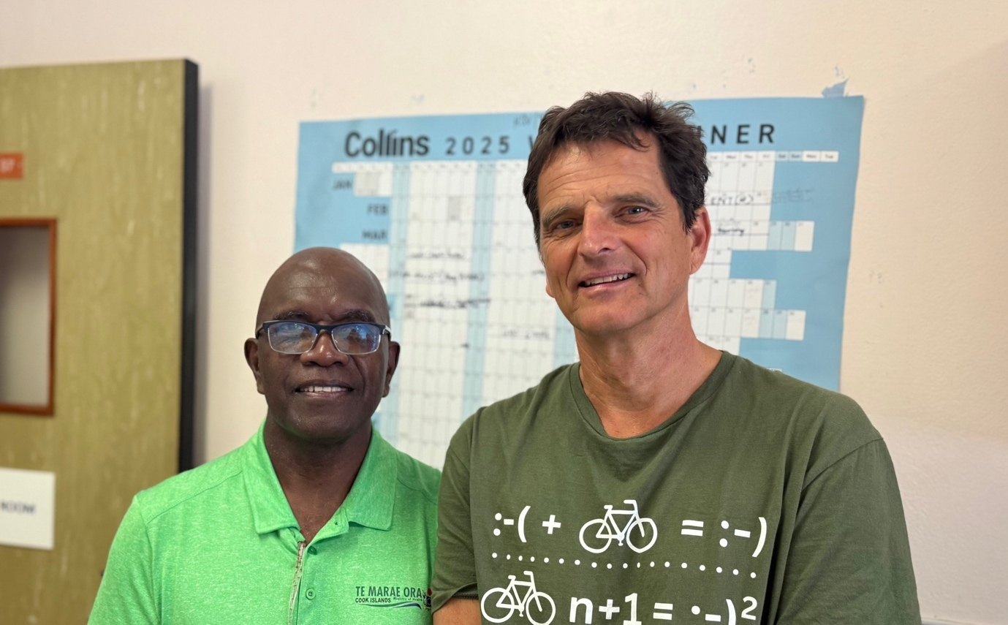
Drs Kevin Bisili, Gynaecologist in Rarotonga, and Dr Michael Kalkoff, anaesthetist.
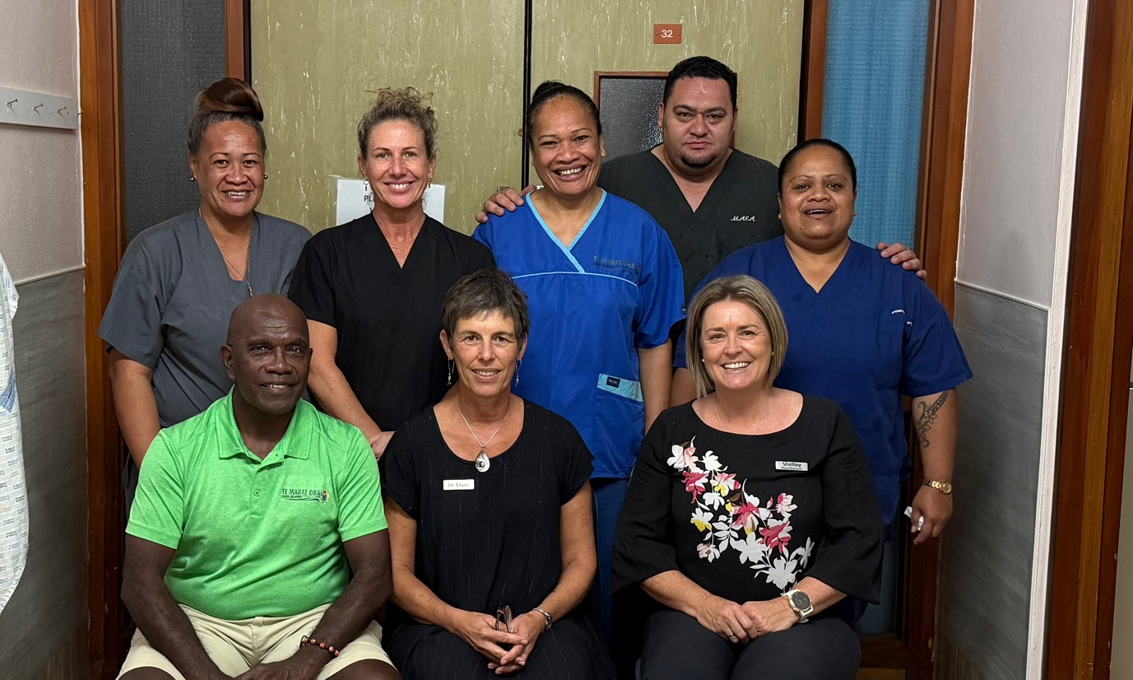
Cook Island theatre team - nurses Kirsten, Rebecca, Joyce (Charge Nurse) and Angie. Behind them, Dr T Maea, anaesthetist.

